Sr. No | Teaching methods | Name of the teachers using the teaching methods
 | Chalk and Board  The lecturer speaks while illustrating the same on the board. The listeners can memorize | Dr. Sangeeta Sankhalkar  Ms. Amisha Shirodker  Ms. Divyarani Revankar  Ms. Eldrika D Costa
 | ICT- Presentations | Dr. Sangeeta Sankhalkar  Ms.Amisha Shirodker  Ms. Divyarani Revankar  Ms. Eldrika D Costa  Ms. Jocelyn Makasare
 | Cooperative learning strategies
 | - Jigsaw  The jigsaw technique is a method of organizing classroom activity that makes students dependent on each other to succeed. It breaks classes into groups and breaks assignments into pieces that the group assembles to complete the (jigsaw) puzzle.in this method the classes are divided into mixed groups to work on small problems that the group collates into a final outcome | Ms. Amisha Shirodker
 | - Round robin  The Round Robin strategy is a brainstorming strategy where students are situated around a table in an academic discussion. Like other brainstorming sessions, students generate ideas on a specific topic or question. | Ms.Divyarani Revankar  Ms. Jocelyn Makasare
 | - Rally table  It is a strategic learning method and comes under cooperative learning method. In this method, the class or the students are divided into groups. This is done to encourage group learning, team building and cooperative learning. | Ms. Jocelyn Makasare
 | - Corners  The Four Corners strategy is an approach that asks students to make a decision about a problem or question. Each of the four corners of the classroom is labelled with a different response (strongly agree, agree, disagree, strongly disagree). Students move to the corner that best aligns with their thinking. | Ms. Jocelyn Makasare
 | Debates  It is a learning method, and functions as a strategy for studying as well. This learner-oriented method is more comprehensive, and bilateral relationship between teacher and learner will occur and each one has his/her own share in the learning and teaching process | Ms. Divyarani Revankar
 | Group discussions  Students are divided into groups and they are encouraged to discuss on the subject matter given. Teacher is in charge of the discussion. After giving lectures teachers encourages the student to participate in group-discussion. | Dr. Sangeeta Sankhalkar  Ms. Amisha Shirodker  Ms. Divyarani Revankar  Ms. Jocelyn Makasare
 | Flipped Classroom learning  Reversing the traditional teaching method. Prior instructions and activities are assign outside class or online. Students bare expected to read, learn through videos, research article s, etc. | Ms. Jocelyn Makasare
 | Student Presentations  Students will be presenting the topic assigned to them by the course teacher . Also used for continuous assesment. Student learn and improve skills of presenting, public speaking, confidence level, knowledge of the topic, etc. | Ms. Amisha Shirodker  Ms. Divyarani Revankar  Ms. Eldrika D Costa  Ms. Jocelyn Makasare  Dr. Sangeeta Sankhalkar
 | Library referencing  Students refer to books in the library and self study | Dr. Sangeeta Sankhalkar
 | Experiential Learning visits  To understand ongoing research in plant sciences and techniques and instruments used. | Dr. Sangeeta Sankhalkar  Ms.Amisha Shirodker  Ms. Divyarani Revankar  Ms. Eldrika D Costa  Ms. Jocelyn Makasare
 | Self learning | Ms. Jocelyn Makasare

COOPERATIVE LEARNING
PAPER: PLANT DRUG TECHNOLOGY AND PHARMACOGNOSY
SEMESTER: V
CLASS: TY BSc
TEACHER: MS. JOCELYN MAKASARE
- Round Robin
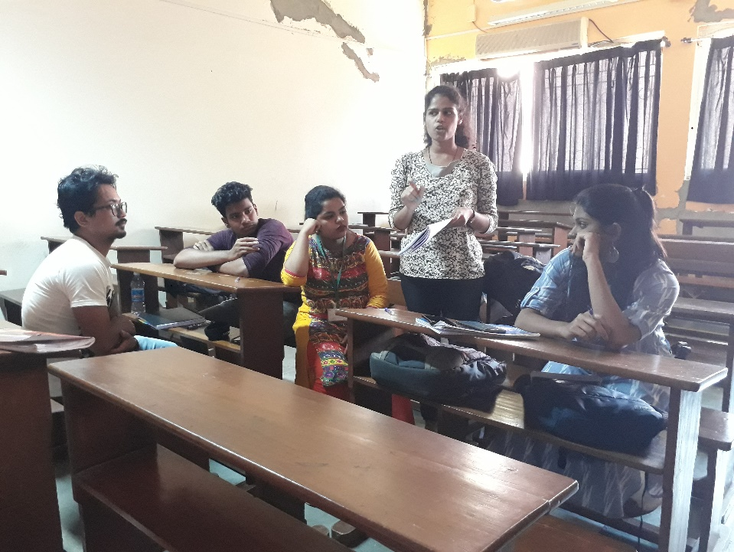
- Rally Table

